# Ecommerce website DBMS Project

**Contents**

* Project Description
* Basic structure
  + Functional requirements
  + Entity Relation (ER) diagram and constraints
  + Relational database schema
* Implementation
  + Creating tables
  + Inserting data
  + Created Functions using python and SQL to obtain relationship
* Queries
  + Basic queries using S QL
  + DDL & DML commands

## Description

## As a Backend Engineer its important to design a database where Customer username and password credentials were created to place an order from the available items or to become a vendor in order to add the items which are available for selling with the rates displayed when user clicks on the item. With the use of Referential Integrity, the relationships are obtained between the tables.

## Basic Structure

### Functional requirement

* A new user can register on the website in the customers table.
* A customer can register as a vendor.
* A vendor can only add items to the items table
* Item quantity can be fetched from the items table.
* A vendor can also delete the not available item by using the delete command.
* A customer can see his orders from the orders table.

### Entity Relation Diagram

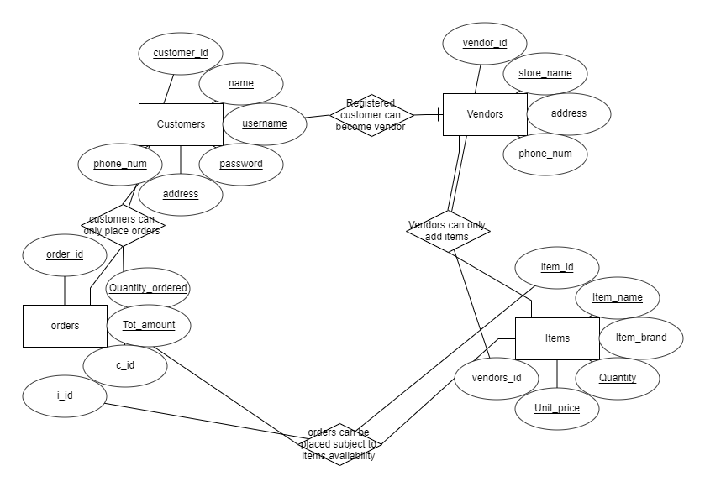

### Relational Database Schema

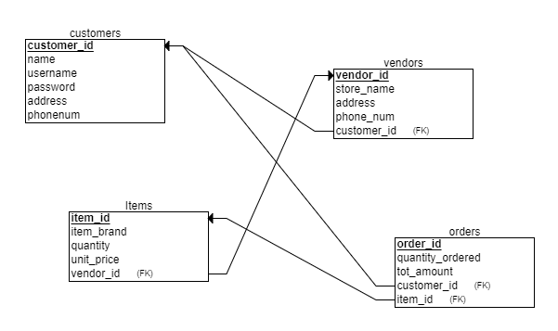

## Implementation

### Creating Tables and Inserting Values

### Altering Tables by adding foreign keys.

* Fetch all from python displays the table contents in each schema.